**Employee Management System - SQL Exercises**

**Exercise 1: Create a Simple View Goal: Create a view to show basic employee details.**

**Task: Create a view named vw_EmployeeBasicInfo that displays EmployeeID, FirstName, LastName, and DepartmentName by joining Employees and Departments.**

**SOLUTION :  
Select Your Database**

CREATE DATABASE EmployeeDB;

GO

USE EmployeeDB;

**Create the Departments Table**

CREATE TABLE Departments (

DepartmentID INT PRIMARY KEY,

DepartmentName VARCHAR(100)

);

**Create the Employees Table**

CREATE TABLE Employees (

EmployeeID INT PRIMARY KEY,

FirstName VARCHAR(50),

LastName VARCHAR(50),

DepartmentID INT FOREIGN KEY REFERENCES Departments(DepartmentID),

Salary DECIMAL(10, 2),

JoinDate DATE

);

**Insert Sample Data**

**Insert into Departments:**

INSERT INTO Departments (DepartmentID, DepartmentName)

VALUES

(1, 'HR'),

(2, 'IT'),

(3, 'Finance');

**Insert into Employees:**

INSERT INTO Employees (EmployeeID, FirstName, LastName, DepartmentID, Salary, JoinDate)

VALUES

(101, 'Asha', 'Sharma', 1, 50000.00, '2021-01-10'),

(102, 'Bala', 'Verma', 2, 65000.00, '2020-03-15'),

(103, 'Chetan', 'Joshi', 3, 60000.00, '2022-07-01'),

(104, 'Divya', 'Mehta', 2, 70000.00, '2023-02-20');

**Create the View vw_EmployeeBasicInfo**

CREATE VIEW vw_EmployeeBasicInfo AS

SELECT

e.EmployeeID,

e.FirstName,

e.LastName,

d.DepartmentName

FROM Employees e

JOIN Departments d ON e.DepartmentID = d.DepartmentID;

**View the Output**

SELECT * FROM vw_EmployeeBasicInfo;

**OUTPUT :**

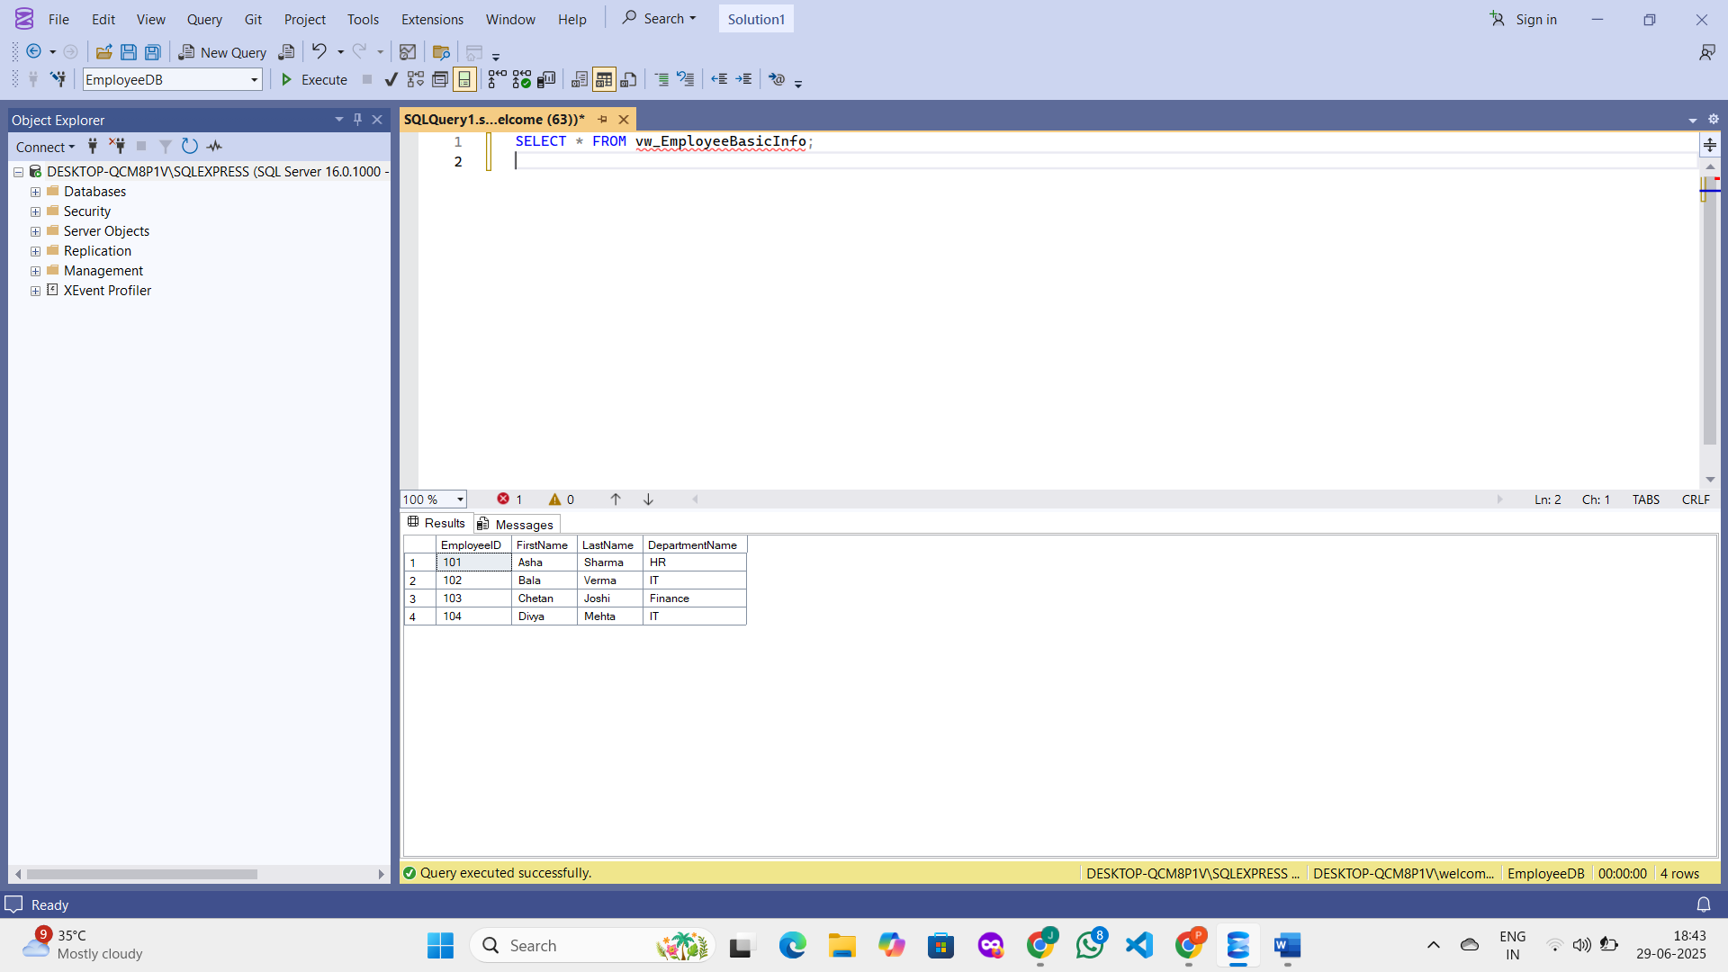

**Exercise 2: Add Computed Column - Full Name**

**Goal: Use a computed column in a view.**

**Task:**

**Modify or create a view named vw_EmployeeFullName that includes a computed column**

**FullName (concatenation of FirstName and LastName).**

**Example Computed Column:**

**FirstName + ' ' + LastName AS FullName**

**SOLUTION :**

**Check if Tables Already Exist**

SELECT * FROM sys.tables;

**Create the View with Computed Column FullName**

CREATE VIEW vw_EmployeeFullName AS

SELECT

e.EmployeeID,

e.FirstName,

e.LastName,

e.FirstName + ' ' + e.LastName AS FullName,

d.DepartmentName

FROM Employees e

JOIN Departments d ON e.DepartmentID = d.DepartmentID;

**View the Output**

SELECT * FROM vw_EmployeeFullName;

**OUTPUT :  
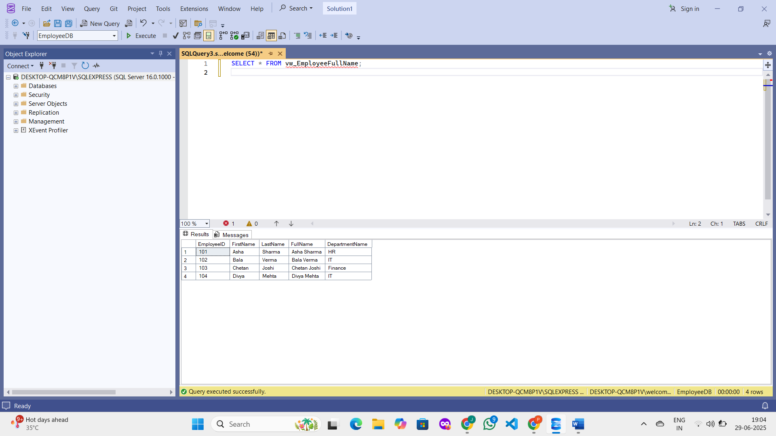**

**Exercise 3: Add Computed Column - Annual Salary Goal: Add a financial computed column.**

**Task: Create a view named vw_EmployeeAnnualSalary that includes a computed column AnnualSalary (Salary * 12).**

**SOLUTION :  
Check for Correct Database**USE EmployeeDB;

**Ensure Tables and Data Exist**

SELECT * FROM Employees;

**OUTPUT:**

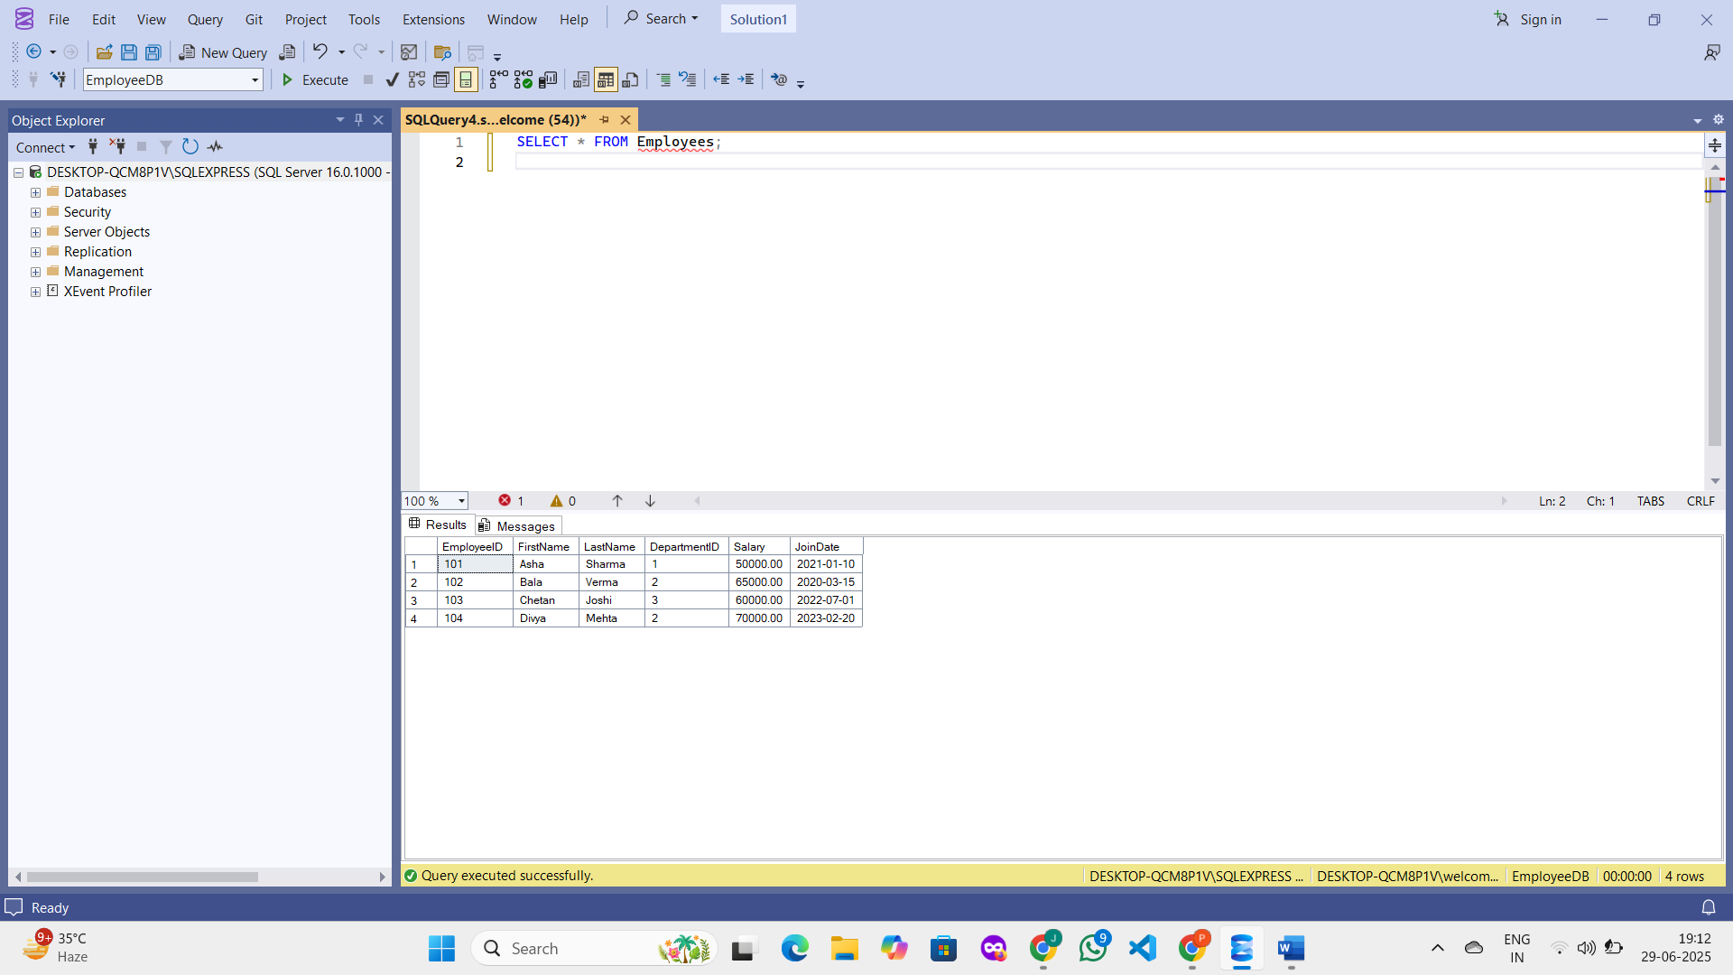

**Create the View vw_EmployeeAnnualSalary**

CREATE VIEW vw_EmployeeAnnualSalary AS

SELECT

EmployeeID,

FirstName,

LastName,

Salary,

Salary * 12 AS AnnualSalary

FROM Employees;

**View the Output**

SELECT * FROM vw_EmployeeAnnualSalary;

**OUTPUT :**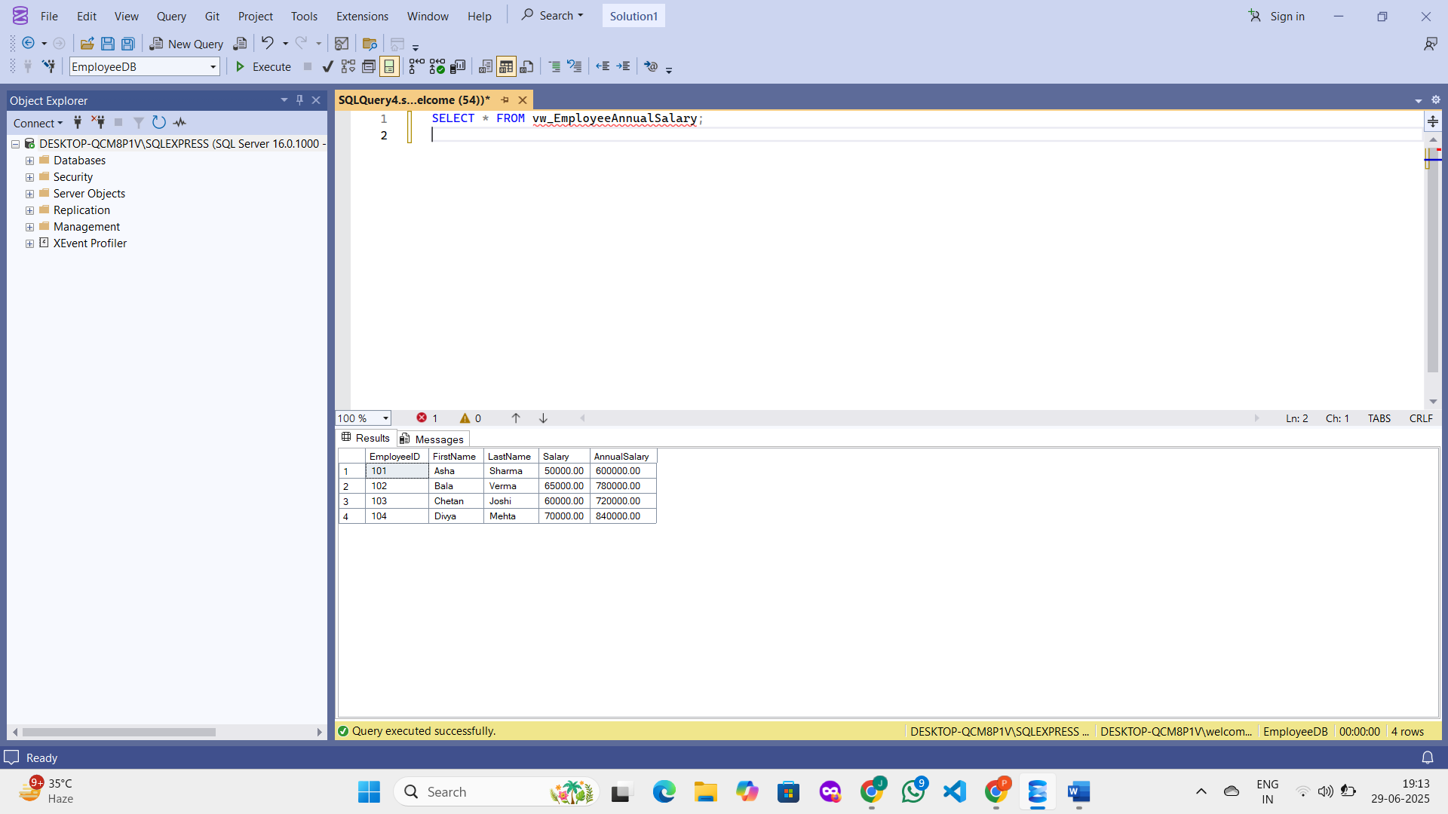

**Exercise 4: Add Multiple Computed Columns**

**Goal: Combine multiple computed columns in a single view.**

**Task: Create a view named vw_EmployeeReport that includes: - EmployeeID - FullName - DepartmentName - AnnualSalary - Bonus (10% of AnnualSalary) Example Bonus Calculation: (Salary * 12) * 0.10 AS Bonus**

**SOLUTION :  
Check for Right Database**

USE EmployeeDB;

**Confirm That Data Exists**

SELECT * FROM Employees;

SELECT * FROM Departments;

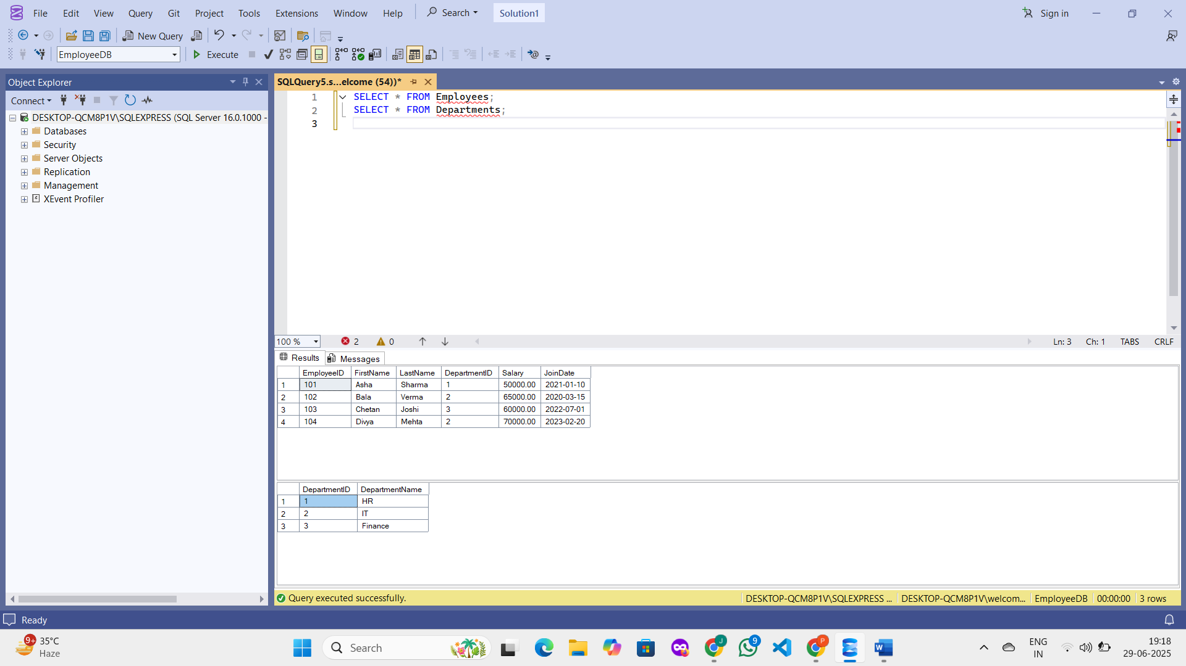

**Create the View vw_EmployeeReport**

CREATE VIEW vw_EmployeeReport AS

SELECT

e.EmployeeID,

e.FirstName + ' ' + e.LastName AS FullName,

d.DepartmentName,

e.Salary * 12 AS AnnualSalary,

(e.Salary * 12) * 0.10 AS Bonus

FROM Employees e

JOIN Departments d ON e.DepartmentID = d.DepartmentID;

**View the Output**

SELECT * FROM vw_EmployeeReport;

**OUTPUT :**

